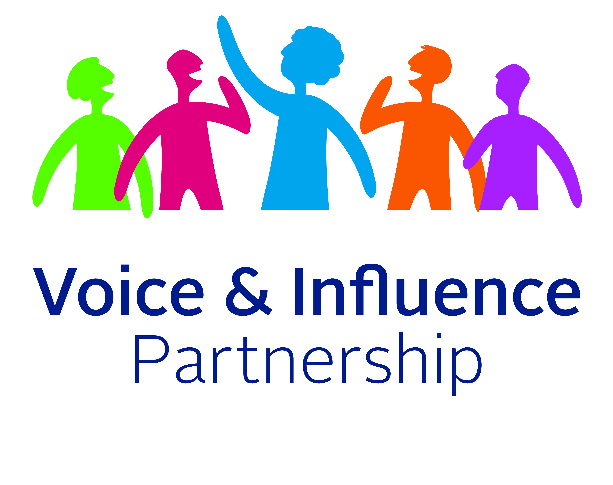
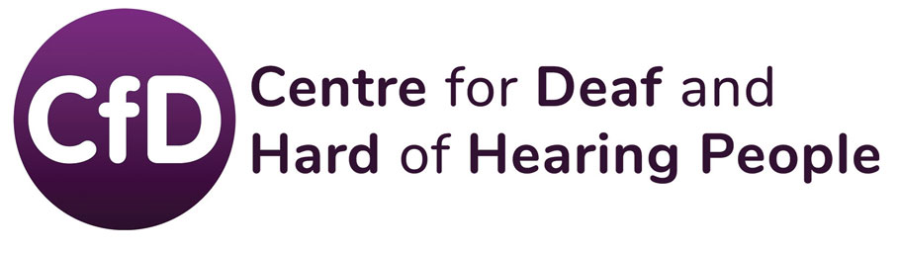

The Centre for Deaf and Hard of Hearing People (CfD) in partnership with the Voice and Influence Partnership (VIP).
Join the Voice and Influence Partnership to learn about local consultations. As a VIP, you will have the opportunity to have your say on the big issues affecting Bristol.
First Name …………………………..
Surname………………………………
Post Code ……………………………..
How would you like to hear from us?
☐ Email (if yes, please provide details below)
Email Address………………………………………………………………
☐ Post (if yes, please provide details below)
Address ……………………………………………………………………...
………………………………………………………………………………….
☐ Text (if yes, please provide details below)
Mobile Number ………………………………………………………………….
Please tick to confirm the following:
☐ I would like to become a member of the Voice and Influence Partnership and receive information about local issues affecting Bristol.
To comply with the new data protections (GDPR) and receive communications from CfD and the Voice and Influence Partnership please tick one or both of the boxes below:

☐ I give consent to CfD to store and process my data.

☐ I give consent to The Care Forum (lead partner of the Voice and Influence Partnership) to store and process my data for the period of the Project.

You have the option to have your data removed and terminate your membership at any time. For removal of your data with CfD please email info@centrefordeaf.org.uk
For removal of your data from the Care Forum, please email VIPadmin@thecareforum.org.uk

Once you have completed the form, please email it to us at office@centrefordeaf.org.uk or send it in the post to:
CfD, The Vassall Centre, Gill Avenue, Fishponds, Bristol BS16 2QQ.

Please let us know if you would like to receive the form in an alternative format. Call us on 0117 9398653, send an SMS text to 07749 313085 or email office@centrefordeaf.org.uk

