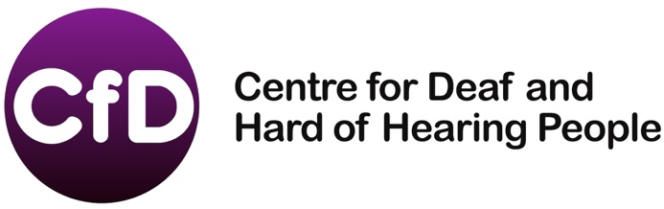
Job Description
Social Media Officer
Bristol
Job Title: Social Media Officer
Location: Bristol Office, Vassall Centre
Line Manager: CfD CEO, David Melling
Terms and Conditions:
This is a part time position of 4 hours per week, Monday to Friday. (Additional hours may be offered in future).
Job Aims :
- To develop CfD use of social media so that we communicate with our target audiences and reach out to new individuals, professionals and groups.
- To contribute to the overall development and promotion of CfD services in Bristol.
- To support the Operations and Marketing Manager and the CEO to market the Equipment Service and the proposed Online Shop.

Key Responsibilities:

- Develop use of social media to market CfD services throughout Bristol.
- Support the CEO in implementing our marketing strategy for a new online shop, including identifying new, cost effective methods for promotion.
- Assist with collection of information and visual material for website/print content
- Coordinate website content
- General day to day coordination of information, press releases and campaign duties.
- Manage deadlines and communicate these across departments
- Maintain and update Social Media platforms (i.e. Facebook, Twitter, etc.)
- Develop good relationships with all relevant bodies.
- Develop video library in BSL to provide information for external viewers via social
media sites

Note: The final interpretation of this job description rests with the Director in consultation with the Trustees and the jobholder. It will be reviewed in the course of supervision meeting and any amendments will be negotiated with the jobholder. The jobholder is also expected to share in other work with CfD as time permits and by agreement with the Director.

CRITERIA | ESSENTIAL | DESIRABLE
Qualifications | Educated to A-Level standard, including Maths and English GCSEs. | Relevant professional qualification  A Marketing qualification or training.
Knowledge, skills and experience | Knowledge and understanding of the voluntary sector and sympathy with the objectives of CfD.
 | At least 2 years' experience of using social media outside of a personal capacity. | Experience of working with Deaf and/or Hard of Hearing people.
 | Experience of using social media and writing content for websites for a range of audiences. | Experience of working closely with colleagues and producing case studies
 | Able to use Microsoft office to a high level. | Understanding of the social model of disability
Abilities |  | Ability to write documents suitable for a range of audiences, including professionals and service-users.

